**[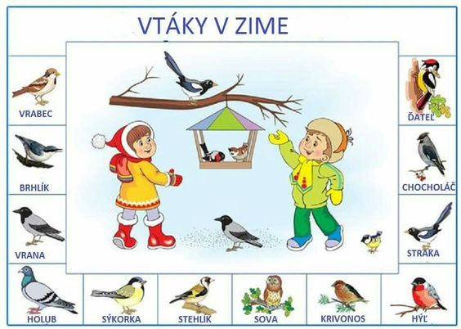](https://s-media-cache-ak0.pinimg.com/originals/a6/e8/d0/a6e8d0c4c3cc39f026a62b8187e299c4.jpg)**

**[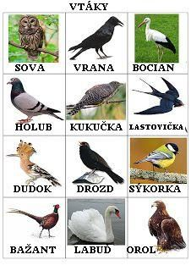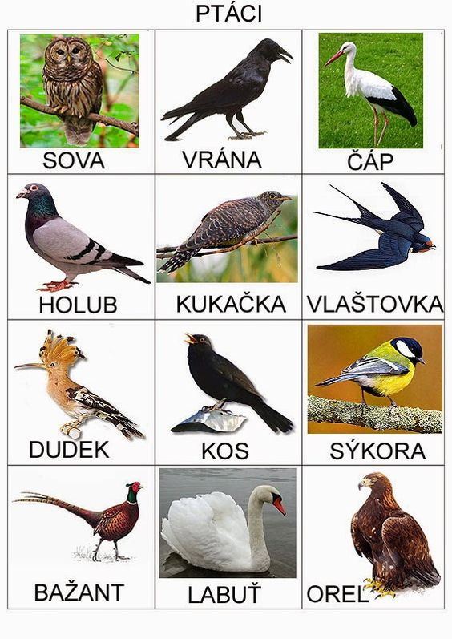](http://prosisu.blogspot.cz/search/label/Komunika%C4%8Dn%C3%AD%20obr%C3%A1zky)**